RESEARCH PROJECT

TOPIC: OPEN WEATHER MUG

PRESENTED BY: IAN KIMANI

INDEX NO: 53410400029

CENTER CODE: 53410400029

PAPER NO: ……..

COURSE: DIPLOMA IN INFORMATION AND COMMUNICATION TECHNOLOGY (DICT)

COURSE CODE: 2920

INSTITUTION: AFRICAN INSTITUTE OF RESEARCH AND DEVELOPMENT STUDIES - ELDORET CAMPUS

SUPERVISOR: MS. CAROLINE KITIENYI

SUBMITTED TO: THE KENYA NATIONAL EXAMINATION COUNCIL (KNEC)

JULY 2020

Table of Contents
RESEARCH PROJECT 1
ABSTRACT 4
CHAPTER ONE 8
1.0 Introduction. 8
1.1 Overview Of The Current System 9
CHAPTER TWO 11
METHODOLOGY 11
2.0 Introduction. 11
2.1 The waterfall model. 11
2.2 Requirements analysis and definition 11
2.4 Implementation and unit testing 12
2.5 Integration and system testing 12
2.6 Advantages of the waterfall model 12
2.7 Prototyping 13
2.8 The prototyping process 13
2.1.4 When is prototyping suitable? 14
2.1.5 Advantages of prototyping 14
2.1.7 Rapid Applications Development 15
2.1.8 Objectives of RAD 15
2.1.9 Principles of RAD 15
2.2.6 Advantages of RAD 16
2.2.8 Conclusion. 17
CHAPTER THREE 18
CHAPTER FOUR 20
CHAPTER FIVE 22
CHAPTER SIX 30
CHAPTER SEVEN 32
References 33

DECLARATION

I hereby declare that this project is an authentic work developed by I, Ian Kimani of African Institute of Research and Development Studies, under the guidance of my supervisor Ms. Carolyn Kitienyi, submitted in partial fulfillment of the requirements for the award of the diploma program in Information and communication Technology.

Developer’s Name: ………………………………………………..
Signature of Developer: ………………………………………………..
Supervisor’s Name: ………………………………………………..
Signature of Supervisor: ………………………………………………..
Institution Name: ………………………………………………..
Institution Code No: ………………………………………………..
Examination Series: ………………………………………………..

ABSTRACT

When we think of weather, we think of the change in patterns that come with the sun, clouds, wind and the precipitation that falls as rain and/or snow. Hence, weather is the state of atmosphere, describing for example, the degree to which it is hot or cold, wet or dry, calm or stormy, clear or cloudy. Over the years, there have been many different attempts on predicting the weather until now, that man discovered technology and sought to use it for the use of forecasting.

Global Weather News is a web application that allows one to view the weather of a certain geographical region with ease. All one needs to do is just click a single button and they are taken to a page that contains the weather of a specific town they would like to see. We have also added a few features to our site that allows the users to get news on other matters as well as an entertainment segment that contains both humor and sports.

In developing our site, we used HTML to come up with the actual website. We used CSS to come up with the neat and elegant format to give an appealing user-interface then we used a little bit of JavaScript in order to make the site responsive and give the user an amazing user-experience of the web application.

Weather forecasting is the application of science and technology to predict the state of the atmosphere for a future time and a given location. Human beings have attempted to predict the weather informally for millennia, and formerly since at least the nineteenth century. Weather forecasts are made by collecting quantitative data about the current state of the atmosphere and using scientific understanding of the atmosphere processes to project how the atmosphere will evolve.

There are a majority of end users to weather forecasts. Weather warnings are important forecasts because they are used to protect life and property. Forecasts based on temperature and precipitation are important to agriculture, and therefore, to commodity traders within stock markets. Temperature forecasts are used by utility companies to estimate demand over coming days.

In some areas, people use weather forecasts to determine what to wear on a given day. Since outdoor activities are severally curtained by heavy rain, snow and the wind chill, forecasts can be used to plan activities around these events and to plan ahead to survive through them.

ACKNOWLEDGMENT.

First and foremost, I would like to thank the almighty God for granting me good health and a sound mind, for the knowledge he has given me to come up with this system and the far he has brought me up to and until now.

Secondly, I would like to thank my sponsor, Mr. John A Green for making sure I went to school without fail, that all my fee was paid for.

Lastly, I would like to thank my lecturers who ensured I got the best understanding of what my course entailed and their constant determination to ensure that I passed my previous tests as well as the annual examinations (KNEC). I would also like to thank my classmates for their humble time and company as we went down this journey together.

TABLE OF CONTENTS

CHAPTER ONE

1.0 Introduction.
THE WEATHER MUG INFORMATION SYSTEM is a system or rather a web application that has been designed to be used by all internet users. The system will be used to read global news all over the globe as well as offer entertainment, sports and humor news.

Unlike other systems before this, the WEATHER MUG INFORMATION SYSTEM has been designed to fit students from primary to secondary departments as well as those pursuing tertiary, college and university studies.

1.1 Overview Of The Current System
The current system will help each and and every internet user access information on the weather with ease. One will just need to click a button and is taken to the page of the town or rather the region they want to acquire the weather of.

To make it more interactive and less monotonous, we added the feature that allows the users to relax their minds. This features a segment that offers memes from the best and most ridiculous articles.

Memes are similar to ‘pans’, only that, they have images, videos and/or pieces of text typically humorous in nature, that is copied and spread rapidly by internet users, often with slight variations.
1.2 Limitations Of The Current System

Like any other system, this too has its flaws that with time, they can and will be solved to meet the needs as well as requirements of each and every user who will prefer to use the Global Weather Mug.

Some of these limitations include:
- Lack of internet connections – Some parts of the country still lack the access to a stable internet connection hence this might be a hindrance when it comes to those who might want to use our site.
- Lack of access to a smartphone or laptop – In order to use the internet, one is required to have access to a smartphone or laptop in order to use our site.
- Inadequate knowledge of how to use the internet – Despite having both an internet connection and internet devices, most people still don’t know how to use the internet and this in turn will cause a hindrance when introducing our site to them.

CHAPTER TWO

METHODOLOGY

2.0 Introduction.

In this chapter the main area of concern is to choose a method that will be most preferable to the project in question and discuss it in detail citing the advantages over other methods and giving the stages involved, the deliverable at each stage and the tools that will be used. The other important part in this task is to compare the chosen method to at least two other methods of system development.

The waterfall model will be compared to the spiral model and prototyping.

2.1 The waterfall model.

The waterfall model comprises four main stages, which are namely; requirements analysis and definition, system and software design, implementation and unit test, finally integration and system testing. The stages have been merged in order to avoid repetitions.

2.2 Requirements analysis and definition

All possible requirements of the system to be developed are captured in this phase. Requirements are set of functionalities and constraints that the end user (who will be using the system) expects from the system. The requirements are gathered from the end-user by consultation, these requirements are analyzed for their validity and possibility of incorporating the requirements in the system to be developed. Finally, a requirement specification document is created which serves the purpose of guideline for the next phase of the model.

This phase also involves the study of the business processes and procedures in order to establish those areas that could be automated to increase efficiency in the organization. The analysis stage also involves stating the project objectives and aims relating to the business under study. Further more the phase goes further by outlining the current system how it functions and the main problems it experiences. Furthermore, a clear description of the users of the current system, their tasks and the challenges they experience while carrying out their tasks. Finally analysis should capture the suggested solutions to the individual’s challenges from their own suggestions and the solutions the system should offer to those problems.

2.3 System and software design.
Before a starting for actual coding, it is highly important to understand what we are going to create and what it should look like? The requirement specification from first phase is studied in this phase and system design is prepared. System design helps in specifying hardware and system requirement and also helps in defining overall system architecture. The system design specifications serve as input for the next phase of the model. The design phase involves detailed description of the system to be developed from the requirements analysis. During this point one has to choose the appropriate design methods, techniques and the desired tools. The key functional and non-functional aspects of the system are also specified in this chapter. The design chapter also covers the physical aspects of the hardware and software as given in the detailed design; this involves the description of the physical setting of the hardware components this include the server, the clients and how information is going to be accessed. System design involves designing several elements, which are namely; data design, process design and interface design. When it comes to designing software the main task is presenting the logical forms of how the real code is going to look like.

2.4 Implementation and unit testing

On receiving system design documents, the work is divided in modules and actual coding is started. The system is first developed in small programs called units, which are integrated in the next phase. Each unit is developed and tested for its functionality; this is referred to as unit testing. Unit testing mainly verifies if the modules meet their specifications. The phase also involves choosing the tools suitable for supporting implementation and a brief description of how the tools were used to achieve the implementation. Once the units have been developed then focus is geared towards transforming the entire system specification into program code and carrying out the necessary tests.

2.5 Integration and system testing
As specified above, the system is first divided in units which are developed and tested for their functionalities. These units are integrated into a complete system during the integration phase and tested to check if all modules coordinate between each other and the system as a whole behaves as per the specifications. After successfully testing the software, it is delivered to the customer.

2.6 Advantages of the waterfall model
- It is easy to identify milestones.
- The standard is mature and many organizations have approved it.
- Quality software is more assured especially for large complex systems.
- Project progress can be evaluated at the end of each phase hence providing management checkpoint.

2.7 Prototyping
It is a model system usually meant for experimentation with the user. It is subset of the system. It contains a small number of the functions that the final system should have. It is a scaled down version of the software to be developed.

A prototype system is an early rapidly constructed version of the proposed system. The prototype is used as a model to represent the final product. Prototyping can be used for a number of reasons.
- To be able to visualize the product to be built.
- To illicit capture requirements of the user.
- Try out options for example designing or interfacing options.
- Justify further funding of the project from the management.
- Give further insight to promote understanding.
Prototyping therefore is an approach in building software systems through the use of prototypes. To be effective a prototype must be developed rapidly so that the customer can asses the results and recommend changes. Prototypes are used to bring the “look and feel” of the final system early in time.

2.8 The prototyping process

2.9 Initial Analysis
This helps to identify the software development resources in order to avoid developing an ill focused system.

2.1.0 Define prototype objectives.
Prototyping should be done after clearly stated objectives because it involves much iteration, which results in further improvements of the prototype. This may make it difficult if there are no objectives. In this case the objectives will be a statement of why the prototype should be used and the functions it should support.

2.1.1 Specify prototype.
Although the prototype is not indented for elaborate use, it is important that it contains the prerequisite functional aspects. It is necessary to understand the prototype from the perspective of the final system.

2.1.2 Construct prototype.
This is building the system model that has to be done quickly and therefore the use of rapid development tools is necessary. Some examples of these tools are; CASE tools, high level language and data development approach among others.

2.1.3 Evaluate prototype.
Evaluation is carried out with respect to the objectives identified at the beginning. Any changes deemed necessary can be involved to enhance the system being developed.

2.1.4 When is prototyping suitable?
Prototyping is suitable under the following circumstances.
- When system requirements are not clear.
- When specifications or requirements are not detailed enough.
- When there is no enough time.
- When the project team has never developed such a system before.
- When quality requirements are not too stringent.

2.1.5 Advantages of prototyping
- Early demonstration of the system helps to identify miss-understandings between developers and users.
- Missing user services can be identified early in time and can be corrected.
- The customer gets the “feel” of the system during demonstration unlike the rigid waterfall process where he needs to be patient until the final delivery.
- There is more user involvement therefore reducing chances of resistance. It also reduces training needs.
- Can be used to justify further funding from the management.

2.1.6 Limitations of prototyping
- Sometimes the prototyping process may get out of hand.
- The customer may force the developer to adopt the working prototype after a “few fixes” and this may bring problems later.
- Prototyping is suitable to systems that are poorly structured. This is because frequent changes to software corrupt software.
- It does not emphasize on documentation because of the rapid iterations and increased cost due to frequent changes.
- It is not appropriate for systems whose malfunction can cause human catastrophe.

2.1.7 Rapid Applications Development
RAD is a software development process that allows suitable systems to be developed within a short time (about 90 days). It aims at reducing the amount of time it takes to build a system without necessarily compromising on the quality of the system. (Rapid does not mean “quick and dirty”).
RAD is also linear sequential process. It involves a mini SDLC that parallels the traditional SDLC phases. It emphasizes on extremely short development cycle, to achieve this therefore RAD has to make certain compromises as well as use certain tools that reduce time and effort.

2.1.8 Objectives of RAD
- Save development time and expense by using project groups to perform a wide range of tasks.
- Provide a working system that could show management evidence that development is possible.
- To analyze and design the business process quickly.
- To avail a viable solution through intense cooperation between users and developers.
- To radically reduce the amount of time it takes to build a system.

2.1.9 Principles of RAD
- End user involvement in the design process.
- Use of the prototyping technique to visualize and make adjustments to the system.
- Use of CASE tools to enforce technical integrity.
- Development of parallel projects and parallel project activities.
- Understanding the requirements well and constructing the scope.
RAD demands customized projects where the application can be broken down into smaller bits.

2.2.0 Stages in RAD
The RAD process comprises of five activities.

2.2.1 Business modeling.
This involves understanding and modeling the business process, identifying the information flow among business functions and modeling them in a way that answers the following questions.
  - What information drives the business process?
  - What information is generated?
  - Who generates it?
  - Where is the information taken?
  - Who processes it?

2..2.2 Data modeling.
This stage re-defines the information from the business-modeling phase into a set of data objectives that are needed to support the business. The attributes of each data object are identified and the relationships between the objects are defined.

2.2.3 Process modeling.
The data objects in the data-modeling phase are transformed to achieve the information flow necessary to implement a business process. Process modeling involves the creation of process descriptions for example for adding, modifying, deleting or retrieving data objects.

2.2.4 Application generation.
Application generation corresponds to the building of the system (coding).this is brought about by the simple fact that the rapid development aspect is involved.

2.2.5 Testing and cut over
Since the RAD process emphasizes on re-use many of the program components must be tested and all the interfaces must be exercised. Implementation can be done alongside some of the testing activities for example user acceptance testing.

2.2.6 Advantages of RAD
- It achieves dramatic time savings.
- Software development is quicker with significant cost savings.
- It is a good alternative if possible risks in development are known.
- It limits the project exposure to external forces of change.
- There is minimized development effort that can be as a result of a number of factors such as use of database approach.
- There is a “tighter fit” between the user requirements and the system developed mainly because of the user involvement.
- It concentrates on essential system elements from the user’s point of view.

2.2.7 Disadvantages of RAD
- It requires sufficient human resources to create the right number RAD teams and this is not always the case.
- Time is saved but with some consequences on software quality.
- Since it makes use of prototyping as one of the techniques then some of the limitations associated with prototyping may manifest themselves

2.2.8 Conclusion.
In this chapter I had gathered information about the methods of system development and compared it to two other methods. I started by describing the waterfall model of systems development and went on to state its merits. From this point I went further and discussed two other methods that are namely the Rapid Applications Development and the Prototyping technique.
The three methods are some of the most preferred method of systems development however I have to make a choice and use one of them. The prototyping technique has several merits some of which are; it acts as an early demonstration of the real system to be developed, the missing user services can be identified later on and changes can be made and finally it can be used to justify further funding. The mentioned advantages however are just a result of one major weakness of this model. That is its suitability because the model is suitable when user requirements are not clear and the specifications are not detailed enough. On the other hand the rapid applications development is the other method that I would wish to draw a closer comparison against the waterfall model.

RAD acquires dramatic time savings and it is quicker with significant cost savings however it is only possible if possible risks in development are known. Since it makes use of prototyping as one of the techniques then some of the limitations associated with prototyping may manifest themselves. As a result I will go for the enhanced waterfall model since it will allow me to work on different phases at any particular time, this model is also advantageous because it is not rigid in nature hence after completion of a particular phase I can still be able to go back and make any changes.

CHAPTER THREE

FEASIBILITY STUDY
3.0 Introduction
As the name implies, a feasibility study is used to determine the viability of an idea, such as ensuring a project is legally and technically feasible as well as economically justifiable. It tells us whether a project is worth the investment – in some cases, a project may not be doable. There can be many reasons for this, including requiring too many resources, which not only prevents those resources from performing other tasks but also may cost more than an organization would earn back by taking on a project that isn’t profitable.

3.1 Scheduling feasibility
This assessment is the most important for project success; after all, a project will fail if not completed on time. In scheduling feasibility, an organization estimates how much time the project will take to complete.
When all these areas have been examined, the feasibility analysis helps identify any constraints the proposed project may face, including:

- Internal project constraints: Technical, Technology, Budget, Resources, etc
- Internal Corporate Constraints: Financial, Marketing, Export, etc
- External Constraints: Logistics, Environment, Laws and Regulations, etc
3.2 Economic feasibility
This is a cost benefit analysis that is evaluated whether the system is economically feasible in grading financial status of the organization thus affording the proposed system will be in addition to purchase, maintenance and training of employees.
It also serves as an independent project assessment and enhances project credibility – helping decision makers determine the positive economic benefits to the organization that the proposed project will provide.

3.3 Operational feasibility
This assessment involves undertaking a study to analyze and determine whether – and how well – the organization’s needs can be met by completing the project. Operational feasibility study also examines how a project plan satisfies the requirements identified in the requirements analysis and phase of system development.

3.4 Technical feasibility
This assessment focuses on the technical resources available for the organization. It helps organizations determine whether the technical resources meet a capacity and whether the technical team is capable of converting the ideas into a working system.
Technical feasibility also involves the evaluation of the hardware, software and other technical requirements of the proposed system.

3.5 Legal feasibility
This assessment investigates whether any aspects of the proposed project conflicts with legal requirements like zoning laws, data protection acts or social media laws.

3.6 Importance Of Feasibility Study
The importance of a feasibility study is based on organizational desire to ‘get it right’ before committing resources, time or budget. A feasibility study might uncover new ideas that could completely change a project’s scope. It’s best to make these determinations in advance, rather than to jump in and to learn that the project won’t work. Conducting a feasibility study is always beneficial to the project as it gives you and other stakeholders a clear picture of the proposed project.

Below are some key benefits of conducting a feasibility study:
- Improves project teams’ focuses
- Identifies new opportunities
- Provides valuable information for a ‘go/no go’ decision
- Narrows the business alternatives
- Identifies a valid reason to undertake the project
- Enhances the success rate by evaluating multiple parameters
- Aids decision-making on the project
- Identifies reasons not to proceed

CHAPTER FOUR

SYSTEM ANALYSIS
4.1 Data Collection
Data collection is also referred to as data gathering or fact finding. It involves looking for crucial facts needed for processing.

4.2 Methods of data collection
Some methods of data collection include interviews,use of questionnaires, observation etc. In most cases, the data is collected after sampling.

Sampling is the process of selecting representative elements(-e.g people,organizations) from an entire group of interests.

Some of the tools that help in the data collection include source documents such as forms,data capture devices such as digital cameras etc.

4.3 Interviews
Interviews should be carried with the relevant stakeholders in order to get views about the current system and gather requirements for the proposed system. The interview method is powerful because it enables the analyst to have face-to-face contact with the interviewee.
The following guidelines should followed when executing an interview:
- The interviewee must be informed in good time and the topic of discussion communicated accordingly.
- Avoid personal biases in your questions.
- Be careful about body language.

4.4 Advantages if interviews
- Non-verbal communication like facial expressions can be used and observed.
- Questions can be rephrased instantly for clarification

4.5 Disadvantages if interviews
- Time consuming
- The interviewee may not fully open up on some issues that may be personal or sensitive.

4.6 Observation
This method requires the observer to participate or watch closely as a person performs activities in order to learn about the system. This method gives the analyst first hand experiences about the problem and exposes them to the system requirements.

The main advantage is that concepts that are too difficult for non-technical stuff to explain can be observed.

The major drawback is that the person being observed might alter behavior leading to wrong requirements being observed and it also consumes a lot of time.

4.7 Stages of data collection
The process of data collection may involve a number of activities. These include:
- Data creation:This includes identification of the data required to meet a specific need and the process of capturing the data in a form that can be input easily into the computer system.
- Data preparation:this is the conversion of the data from the source documents to machine readable format. If the data is captured already in electronic format,it may not be transcription.

4.8 Data input
Data input refers to a process where the collected data is converted from human readable form to machine readable form.

- Media conversion: Data may need to be converted from one medium to another eg from a floppy disk to a hard disk.
- Input validation: Data entered into the computer is subjected to validity checks before being processed to reduce errors at the input.
- Sorting: In case the data needs to be arranged in a predefined order, it is first sorted before processing

4.9 Processing
This is the transformation of input data by the CPU to a more meaningful output (information).

4.1.0 Output
The final activity in data processing cycle is produced in the desired output also referred to as information. Distribution is making the information available to those who need it and is sometimes called information dissemination.

CHAPTER FIVE
SYSTEM DESIGN
5.0 Document Object Model (DOM)
This is a cross-platform and language-independent interface that treats an XML or HTML document as a tree structure where each node is an object representing a part of the document. The DOM represents a document with a logical tree.

Each branch of the tree ends in a node, and each node contains objects. DOM methods allow programmatic access to the tree; with them, one can change the structure, style or content of a document. Node can have event handlers attached to them. Once a event is triggered, the event handlers get executed.

The principal standardization of the DOM was handled by the ‘World Wide Web Consortium’, which last developed a recommendation in 2004. WHATWG took over the development of the standard, publishing it as a living document. The W3C now publishes stable snapshots of the WHATWG standard.

5.1 Applications Of DOM
5.2 Web browsers
To render a document such as HTML page, most web browsers use an internal model similar to the DOM. The node of every document are organized in a tree structure, called the DOM tree, with the topmost node named as “Document Object”. When an HTML page is rendered in browsers, the browser downloads the HTML into local memory and automatically parses it to display the page on the screen.

5.3 JavaScript
When a web page is loaded, the browser creates a DOM of the page, which is an object oriented representation of an HTML document that acts as an interface between JavaScript and the document itself. This allows the creation of dynamic web pages, because, within a page JavaScript can:

- Add change and remove any of the HTML elements and attributes.
- Change any of the CSS styles.
- React to all the existing events.
- Create new events.

DOCUMENT OBJECT MODEL(DOM)

Document

Root Element:<html>

Element:<body>
Element:<head>
Text: <My Title>
Element: <Title>
Attribute: ”href”
Text:” My link”
Text: “My Header”
Element: <a>
Element: <h1>

5.5 CSS Object Model
The CSS Object Model is a set of APIs allowing the manipulation of CSS from JavaScript. It is so much like the DOM, but for the CSS rather than the HTML, it allows users to read and modify CSS styles dynamically.

5.6 Application Programming Interface (API)
An API is a software intermediary that allows two applications to talk to each other. Each time you use an application like Facebook to send an instant message or to check the weather on your phone, you’re using an API.

When you use an application on your mobile phone, the application connects to the internet and sends data to the server. The server then retrieves that data, interprets it, performs the necessary action and sends it back to your phone. The application then interprets that data and prevents you with the information you wanted in a readable way. This is what an API is – all of this happens via API.

5.7 Web Hosting
When a hosting provider allocate space on a web server for a website to store its files, they are hosting a website. Web hosting makes the files that comprise a website (code,images, etc) available for viewing online. Every website you have ever visited is hosted on a server.

5.8 Netlify
Netlify is a web developer platform that multiplies productivity. By unifying the elements of the modern decoupled web from local development to advanced edge logic. Netlify enables a 10x faster path to much more performance, secure and scalable websites and apps.
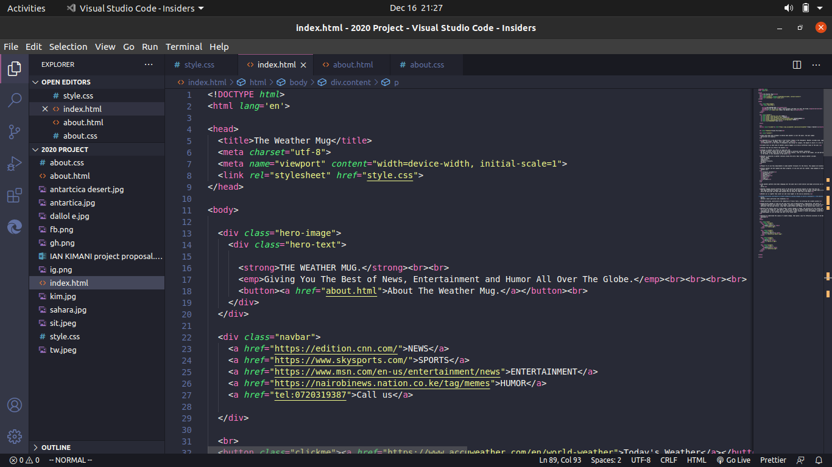

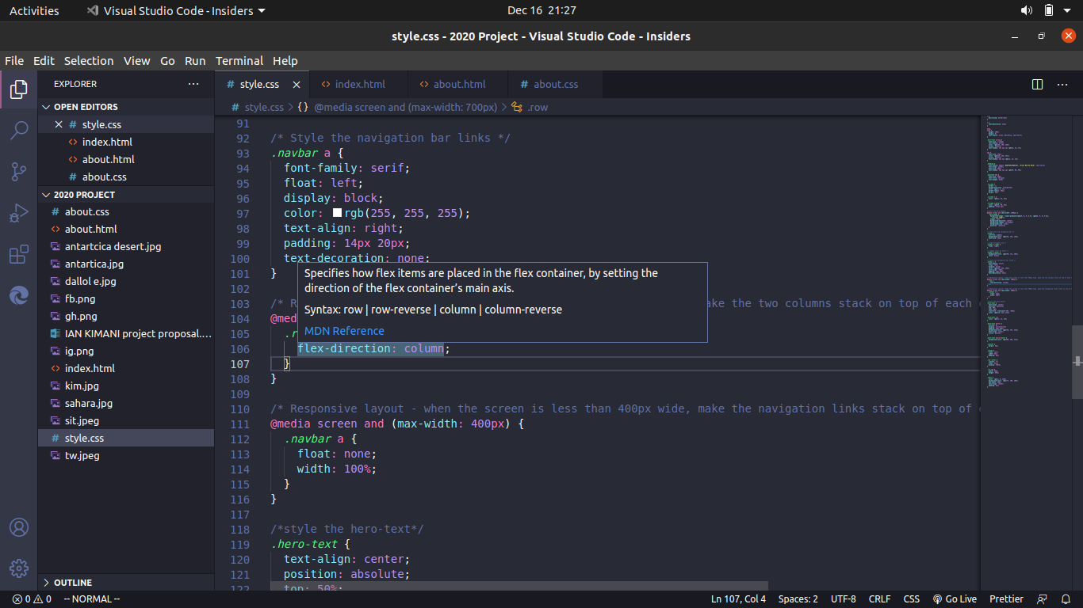
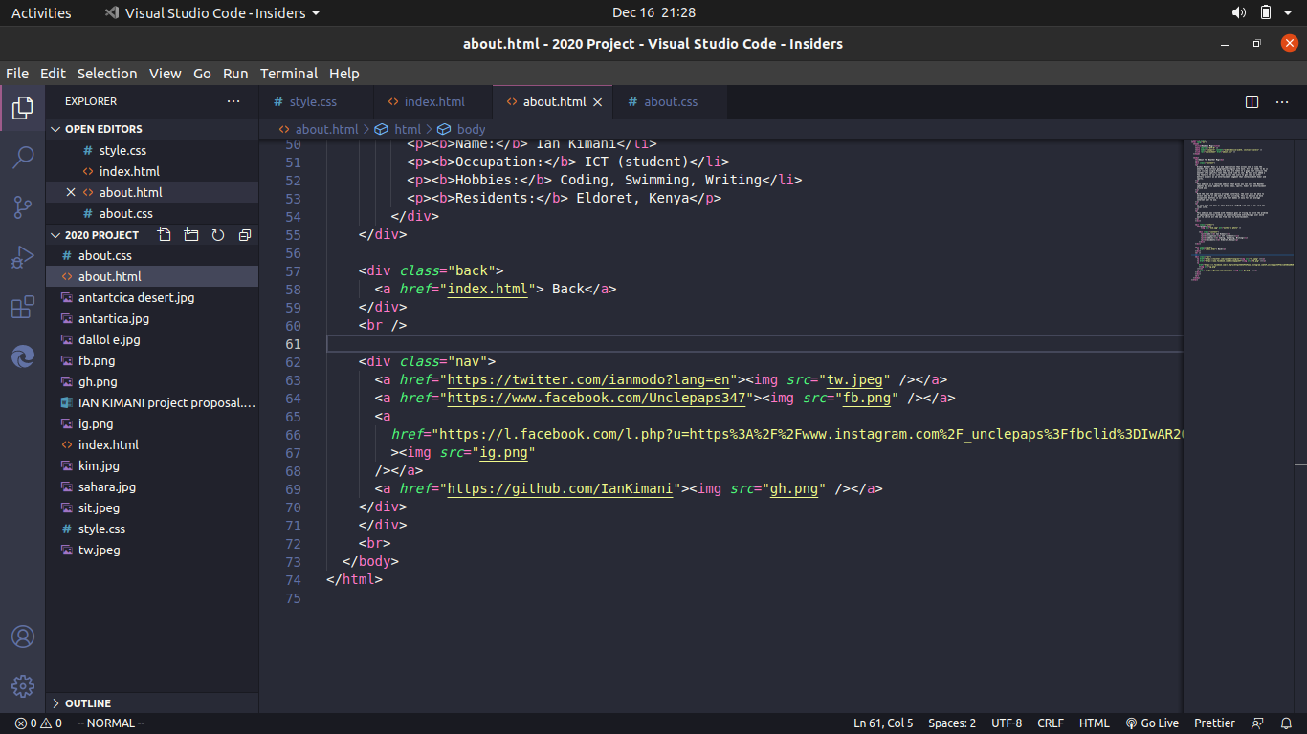
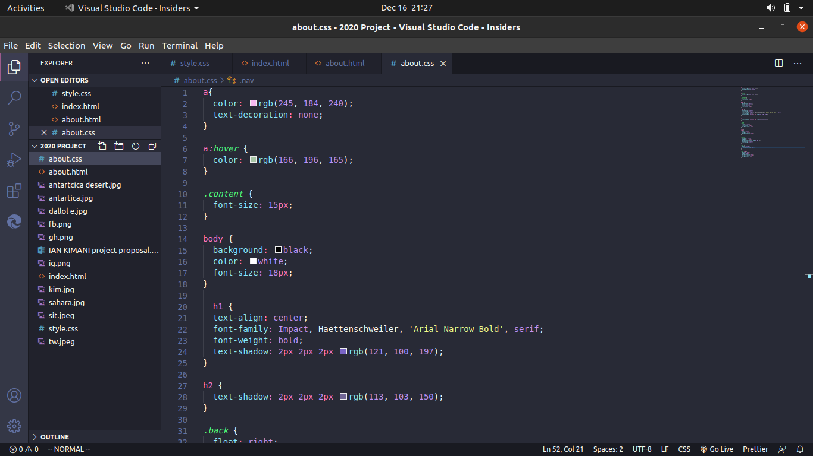
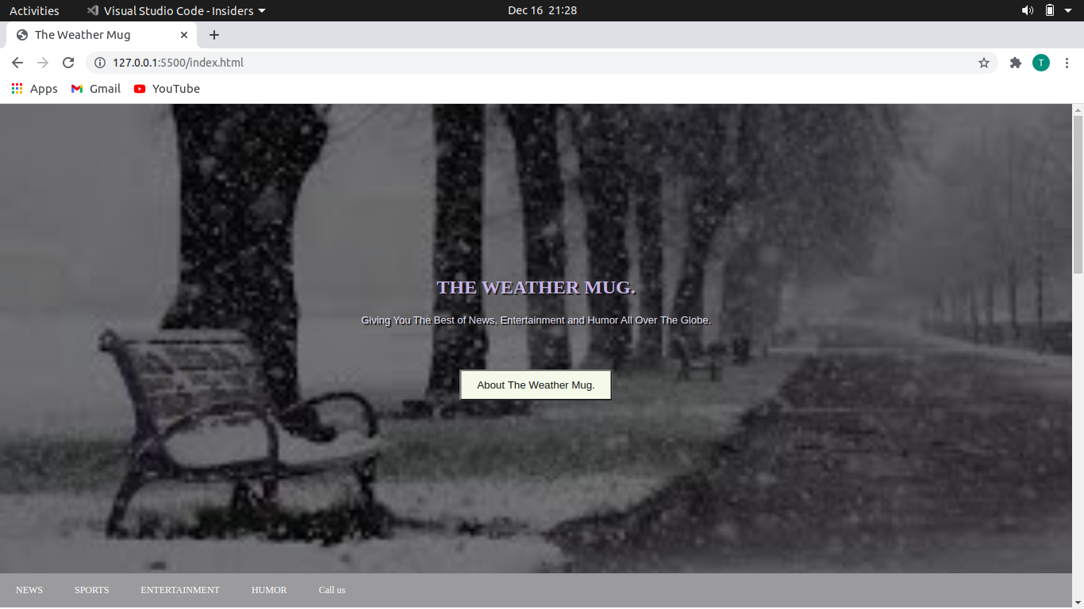

CHAPTER SIX

SYSTEM IMPLEMENTATION
6.0 Introduction
System implementation is the process of delivering the system for use in day-to-day operating environment for the users to start using it. The areas to be addressed during system implementation include file conversion, staff training and changeover strategies.

6.1 File conversion
Every time a new system is implemented, the format of data files might require modification or change. This process is referred to as the file conversion. A new system may require a change in file format.

The factors to consider at this point are:
- Whether the new system requires a new operating system and hardware.
- Whether you need to install new application software.
- Whether you need to create new data database files for the new system.

6.2 Staff training
Availability of appropriate documentation like user manuals goes a long way to make staff training easy, quick and effective. System implementation can fail if the staff are not trained properly leading to great loss of the company resources.

6.3 Changeover strategies
Changeover simply means how to move from the old system and start using the new. Most businesses especially those that are driven by information technology need a smooth changeover as possible.
Some of the system changeover strategies are:

6.4 Straight changeover
In straight changeover, the old system is stopped and discarded and the new system started immediately. This sudden old to new means that the project faces higher risks in case the new system faces problems. This is because the old system would not be there to fall back to. The advantage of the method is that it is cheaper because you do not have to run the two systems in parallel.

6.5 Parallel changeover
In parallel changeover, both the old and the new system are run parallel to each other for some time until users have confidence in the new system then the old system is phased out. The method is a bit costly because extra resources have to be engaged to run the two systems in parallel.

6.6 Phased changeover
In phased changeover, a new system is implemented in phases or stages. A good example is how the education system is changed from the old to the new curriculum. Sometimes, one phase may run a new system for testing before it is implemented into all the other phases. This is called piloting

6.7 Security control measures
Information and data security have become some of the most important aspects of information systems. A lot of careful planning has to be done in order to have what is called inbuilt security in the system. This is because information is under constant threat of being illegally accessed or disclosed to unauthorized parties.

Therefore, the system implementer must make sure that the security features built in the system are properly configured during the implementation stage.

CHAPTER SEVEN

SYSTEM MAINTENANCE AND REVIEW
7.0 System maintenance
System maintenance is the adjustment and enhancement of requirements or correction of errors after the system has been implemented. Regardless of how well the system is constructed and tested, errors may be detected when the system is in use.

7.1 System review
System review is a formal process of going through the specifications and testing the system after implementation to find out whether it still meets the original objectives. The act is sometimes called review and audit. If the system does not meet the stated objectives, system development might start all over again.

References

  - The weather burgle by Ian Chemweno by 2020
  - Hosting and authoring on the web by James Patrick 2013

